**11)FREQUENCY SAMPLING METHOD:**

**clc;**

**clear;**

**close;**

**N=input("Enter the value of N:");**

**U=input("Enter the value of U:");**

**for n=0+U:1:N-1+U**

**h(n)=(1+cos(2*%pi*(7-n)/N))/N;**

**end**

**[hz,f]=frmag(h,256);**

**hz_dB=20*log10(hz)./max(hz);**

**figure;**

**plot(2*f,hz_dB);**

**a=gca();**

**xlabel('Frequency w*pi');**

**ylabel('Magnitude in dB');**

**title('Frequency Response of FIR LPF');**

**xgrid(2);**

**OUTPUT:**

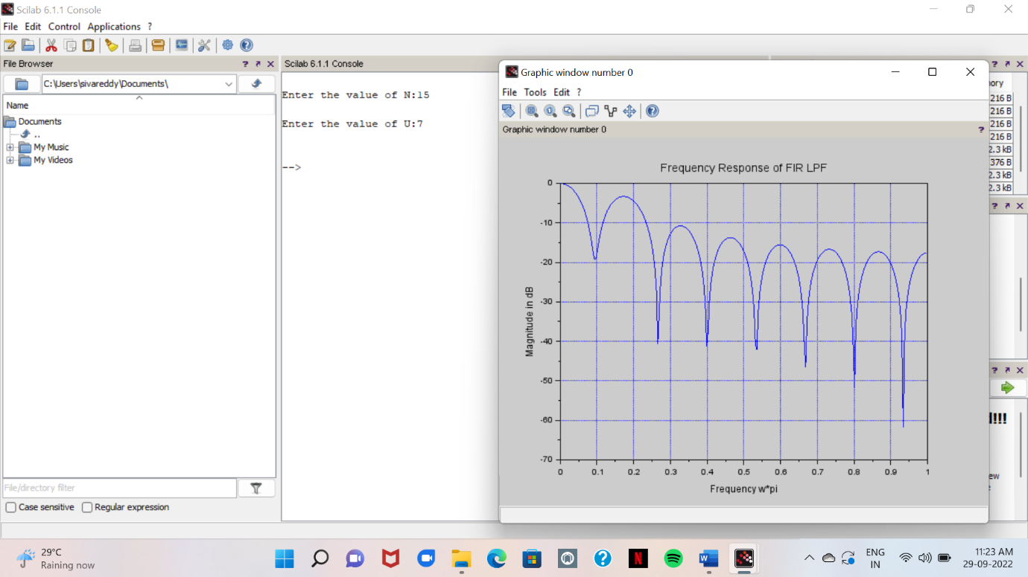

**12)DECIMATION:**

clc;

close;

N=input('input length of the input signal sequnce');

M=input('downsampling factor=');

*//generate the input sequence for the specified length N*

n=0:N-1;

*//m=0:N*M-1;*

x=n;

disp(x);

*//generate the upsampled signal*

y=x([1:M:length(x)]);

disp(y);

*//plot the input sequence*

subplot(2,1,1);

plot2d3(n,x(1:N));

title('input sequence');

xlabel('time n');

ylabel('amplitude');

subplot(2,1,2);

plot2d3(y);

title('Decimated sequence');

xlabel('time n');

ylabel('amplitude');

**OUTPUT:**

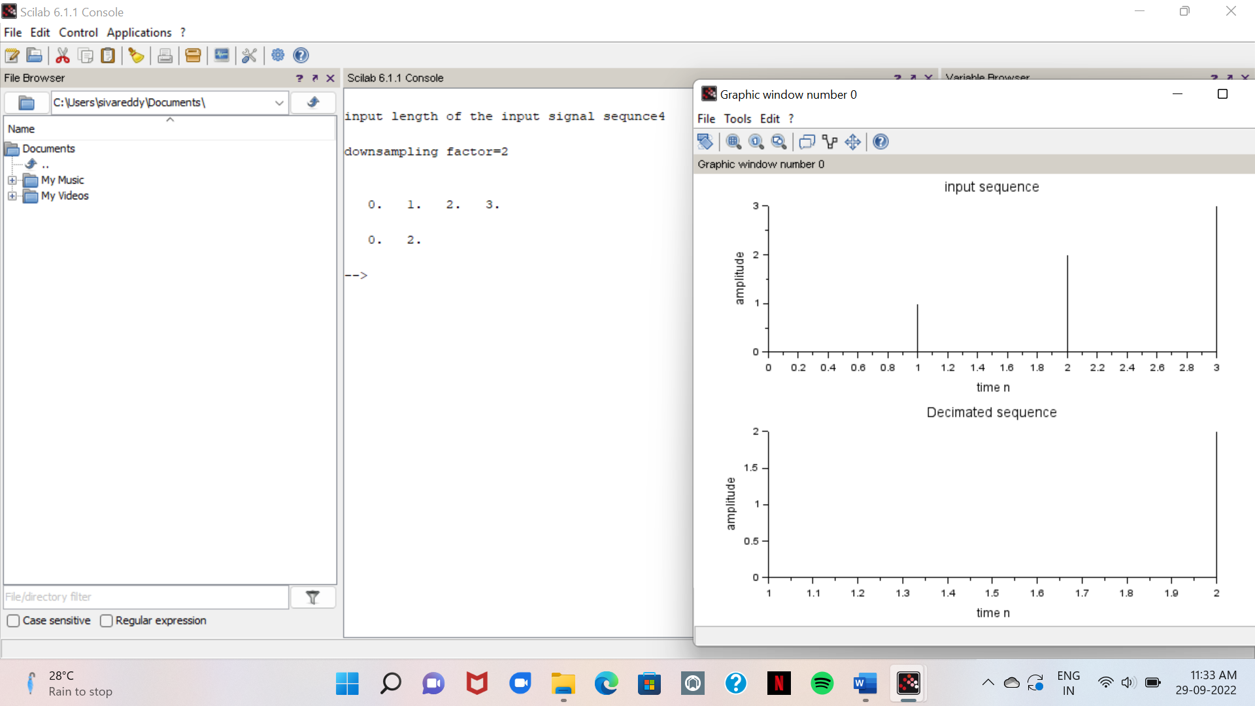

**13)UP SAMPLING:**

**clear;**

**clc;**

**n = 0:%pi/150:2*%pi;**

**x = sin(%pi*n); *//original signal***

**upsampling_x = zeros(1,2*length(x)); *//upsampled by a factor of 2***

**upsampling_x(1:2:2*length(x)) = x;**

**subplot(2,1,1)**

**plot(1:length(x),x);**

**xtitle('original signal')**

**subplot(2,1,2)**

**plot(1:length(upsampling_x),upsampling_x);**

**xtitle('Upsampled Signal by a factor of 2');**

**OUTPUT:**

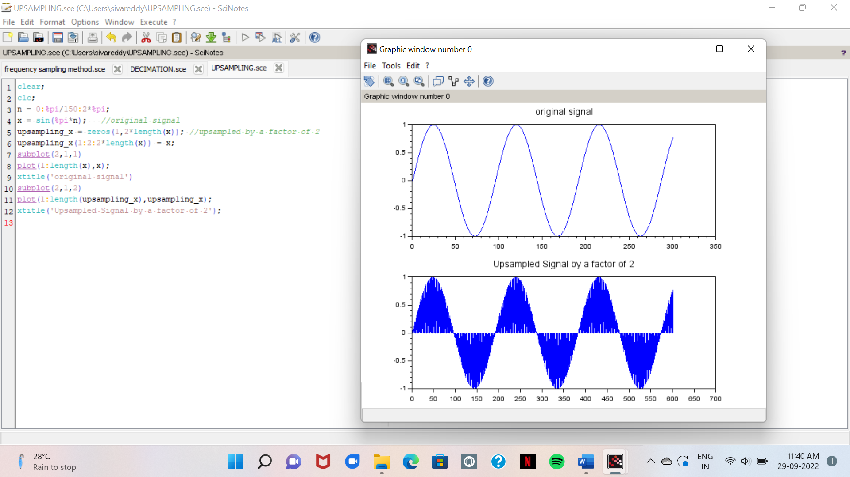

**14)DEAD BAND INTERVAL:**

clc; clear; n=-1; y=12;

flag=1; while n<8

n=n+1;

y=[y 0.9*y(n+1)];

yr=round(y);

end;

disp('n=',n);

disp('y(n)-exact',y);

disp('y(n)-rounded',yr);

disp('Deadband interval ',[-yr(n+2) yr(n+2)])

OUTPUT:

